

The Impact of COVID-19 in UK Financial Market

Abstract:
The goal of this study is to see how the COVID-19 pandemic would affect the UK financial sector. Any country's financial market is defined as the location where securities are bought and sold. This is not a tiny issue, but rather a large circle in which various aspects are intertwined and play a critical role in economic development and financial market stability. Almost all nations were affected by the COVID-19 epidemic, and economic conditions were harsher at the time. To research the issue, a review of past literature is conducted, followed by the development of a theoretical framework that includes qualitative components. Several factors were found from the population, including major businesses that contribute significantly to the economy, interest rates, currency rates, inflation rates, and so on. These variables have a direct impact on the UK's economic development and financial market. The study is carried out on each element, and it is found after a thorough examination that there is still a major influence on the UK financial sector. The market was dropping in February 2020, and there were no investors. The rate of inflation was high, debt interest rates were rising, and market behavior was shifting. The decline remained seen until December 2020. Policymakers took smart decisions in 2021 so that they might recover quickly now that the epidemic has been contained and the market has stabilized.
Table of Contents
1. Introduction 4
1.1. Aims of the Research 5
1.2. Objectives of the Research 6
1.3. Research Motive 6
2. Research Methodology 7
3. Literature Review 9
3.1. Response of Financial Market 9
3.2. Impact of Coronavirus disease on Financial markets 10
3.3. The stock market's response to CORONAVIRUS DISEASE 11
3.4. British Stock Market 13
3.5. Conceptual framework 14
Black Swan Theory 14
Prospect Theory 15
4. Findings and Discussion 16
4.1. Main Contributors Towards Economy 16
4.2. Inflation & Interest Rate and Impact on UK Financial Market 19
4.3. Stock Market and Changing Behavior of Investors 22
4.4. Overall Impact on GDP, Economy and Financial Market in UK 22
5. Conclusion and Financial Market in UK Now 26
References 28

List of Figures:
Figure 1: During Pandemic new work construction output and historical trend 16
Figure 2:Manufacturing Industry Sales during Pandemic 17
Figure 3: Food and Beverage Services Impact of Pandemic 18
Figure 4: UK CPIH, OOH component and CPI 12-month inflation rates 19
Figure 5: Expenditure Share in UK from 2020 to Quarter 1 of 2021 20
Figure 6: UK Official Interest Rates 21
Figure 7: UK GDP from 2008 to 2020 23
Figure 8: UK Monthly GDP along with industry movement 24
Figure 9:UK Monthly GDP index from 2007 to December 2021 24

Introduction
Every industry in the globe was damaged by COVID-19, causing economic instability as certain nations suffered considerable issues while others faced challenges due to concentration of industries that had less challenges as a result of the epidemic. Some industries were hard damaged because activities were halted, while others, such as e-commerce, were thriving since the ball was in their court. The epidemic had a detrimental influence on businesses all around the United Kingdom. Because certain portions suffered significant losses while others were spared, the damage was not distributed evenly. This was due to government limitations to contain the spread, and there was a cross-country lockdown. Borders were shut down, and all import and export chains were disrupted. From 2020 to 2021, UK businesses reported a 21 percent drop in revenues and a 26 percent drop in investments. In the United Kingdom, 70% of businesses have said that this has been a difficult moment in which they have lost investments and income (Dave, 2020). These variables have a direct influence on the UK financial market. Apart from that, the industrial sector was the most vulnerable since it requires physical interaction, and because of the limitations, all activity was halted. Manufacturing was down as the government took efforts to prevent the spread of the disease. In the initial wave of the epidemic, income from gyms, restaurants, dine-in services, travel firms, and other businesses dropped by more than half. (Yuntong, 2022)
Financial intermediaries, such as banks, were having trouble dealing with the deteriorating economic situation. Previous research has found that events related to the COVID-19 pandemic had a major impact on the stock market. When there were crises between 2007 and 2009, there were some events that turned out bad and had a negative influence on the financial market of the United Kingdom, but there were also certain variables that turned out positive and had a positive impact on the financial market of the United Kingdom. The influence of CIVID-19 has been noticed in major countries' stock markets (Mohsin, 2020). According to research, the Tokyo Stock Exchange (TSE) fell by 27%, the Dow Jones fell by 29%, and the Financial Times Stock Exchange (FTSE) fell by 33% between January and March 2020. Furthermore, the influence may be observed in the unemployment rate in the United States of America (USA), which was 14.7 percent in April 2020, compared to 3.6 percent in January 2020. As a result, this rate has dramatically grown in a short period of time, indicating stock market uncertainty. As a result, the unemployment rate in the United Kingdom remained steady during this time, at 3.6 percent. The fact that furloughed workers are still regarded as employed, despite the fact that their pay is paid by the government, is one explanation for these constant figures. (Sherif, 2020)
Banks, often known as financial intermediaries, are the backbone of the country's financial system. Financial intermediaries are referred to as "middle men" because they play an important role in obtaining financing and act as a link between the borrower and the lender. In terms of the financial market in the United Kingdom, the financial system is based on its central bank, the Bank of England. It oversees all policies, including the national debt, financial system, and currency distribution. The current analysis clearly indicates that the influence of the COVID-19 epidemic on the stock market and financial system of the United Kingdom (ZEREN, 2020). With the exception of the CSI 300 index, all markets underperformed throughout the epidemic. It is also clear that the markets fared exceptionally well prior to the epidemic and have taken a substantial impact during pandemics. The COVID-19 issues have had a substantial influence on the economic circumstances of all sectors, which has a direct impact on the country's financial market. Investors, the general people, and policymakers were all aware that this pandemic would be a difficult time for them, with a negative influence on the country's economy (Ozkan, 2021). COVID-19 had an unforeseen influence on the UK financial sector, which was attributable not just to the lockdown, but also to changes in spending behavior among corporations, households, and investors. When the stock market begins to decline, most investors withdraw their funds, which is one of the reasons for the considerable decline in the financial market and the tiny investments witnessed at this time. Furthermore, investment decisions are dependent on a company's net assets and growth, and throughout the pandemic, significant companies' present and budgeted conditions were declining. There was no such evidence on which to base positive projections, which resulted in a major drop in company investment. (Niall, 2020)
The goal of this study is to look at the influence of COVID-19 on the UK financial sector. Following the preceding discussion, there are key grounds on which the research's goals, objectives, and motives might be formed, which are mentioned below:

Aims of the Research
Having the detailed discussion on the topic and to make the proper research the aim of the paper is to investigate:
What is the impact of COVID-19 pandemic on the financial market of UK a leading economy? The change in behavior of investors were also the main cause of significant downfall?

Objectives of the Research
The study's goal is to look at the impact of a pandemic on the UK financial sector, with the following research objectives:
- The objective of this report is to look at the influence of the COVID-19 pandemic on the profitability of the key industries in the UK market, which has an impact on the financial market.
- The objective of this report is to look at interest rate and exchange rate fluctuations caused by the COVID-19 pandemic, which might have a negative influence on the financial markets.
- To look at the effects of a pandemic-related shutdown on the UK financial industry.
- To look into policymakers' choices against the financial sector in the UK during a pandemic crisis.
- To sum up the impact of the COVID-19 epidemic on the financial markets in the United Kingdom.

Research Motive
The research's approach is to examine the literature on the issue in depth, with the goal of having a thorough examination of past literature on the topic, which is "the influence of the COVD-19 epidemic on the financial markets of the United Kingdom." To achieve the goal, the job begins with a solid technique based on earlier research. Previous research has looked into a variety of topics, including the influence on the global financial market, how firms cope with unexpected occurrences, stock market declines, and so on. Each study has a relationship, and a few holes can be found in order to complete this research project. Following a thorough examination of the literature, the research is focused on determining the impact of a pandemic on the financial markets of the United Kingdom.

Research Methodology
The qualitative approach and the qualitative approach are two sorts of methodologies that may be used in research. Some previous research used a hybrid approach as well. This research is based on a study of previous material and discussion of results such as gaps in the prior literature. Second, the topic is to explore the influence of a pandemic on the financial markets of the United Kingdom, which contains various factors, and building a quantitative foundation will not be adequate to achieve the research's goal. This study will be based on theoretical evidence with some quantitative features to substantiate the conclusion, taking into account this qualitative aspect. Previous research have used this approach as well.
There are two sorts of studies that may be used in the research. The first is a primary study that is created from the ground up and carried out for the first time. This technique was not appropriate for the issue, which is why secondary sources and an approach were used in the paper. Secondary data is information that has already been researched and may be used for additional study based on the premise of relevant and credible data. Articles, journals, papers, news, and other secondary sources were utilized in the research. Google Scholar and reputable websites such as Financial Times were the primary sources of information. The fundamental restriction of the sources was the relevance of information, for which a large amount of time was spent in order to obtain high-quality data on which to draw conclusions.
Sampling is the next stage. The financial market, in which various factors were engaged, served as the study's population. There was no requirement for adequate sampling because the research used a literature review technique, which was then used to investigate qualitative features and provide support through quantitative components. The selection of factors on which the findings and debates are based are the most important parts. The following are the primary variables discovered for this project:
Main contributors towards economy: Each nation has distinct industries that are major stock market participants and also contribute significantly to the country's economic growth. Manufacturing, construction, and tourism are the three primary businesses in the United Kingdom that contribute significantly to the financial market and economic growth. These factors will be examined in order to determine the impact of a pandemic on the financial markets.
The London Stock Market (FTSC 100): The London Stock Exchange (FTSC 100) is a stock exchange in London, England. In the United Kingdom, there are several stock exchanges, one of the major of which is the FTSC 100, which will be researched particularly for the impact of a pandemic on the financial markets. The conversation will be centered on all stock exchanges, but the focus will be on the main market because the FTSC 100 has a considerable influence, according to the initial discussion.
Stock Market Response to Pandemic: This is another essential variable included in the study since it was predicted that the impact of the COVID-19 pandemic would be worse during the first wave, and stock market responses are crucial in determining the influence on the broader financial market.
Changing behavior of investors: Individual investors, firms, and banks all have a significant influence in influencing the country's financial sector. According to previous research, the major influence on the financial market was attributable to investors' shifting behavior as a result of the epidemic.
Exchange rate: The degree of exchange rate variance has a direct influence on the country's actual economy and financial market. When the exchange rate fluctuates, the price of imported items fluctuates as well. Because the exchange rate is linked to the rate of inflation and interest, this has an influence on market performance. This is a key point to examine in order to get a conclusion about the influence of the epidemic on the UK financial sector.
Interest rate: Another crucial component is the interest rate, as there is a rule of thumb that when the Federal Reserve lowers the interest rate, the economy improves. When interest rates are raised, the financial market booms, and when interest rates are decreased, the financial market plummets. Because there is a direct link between the financial market and the COVID-19 pandemic, this is a crucial variable to explore.
Inflation rate: This variable is linked to the financial industry since interest rate changes affect the pool of borrowers and lenders. Agents are more interested in borrowings than loans when there is rising inflation. When inflation is strong, the bank must pay a high interest rate, making it advantageous for the agent to borrow. This alteration has a key role in the money market, which will be explored in relation to the pandemic in order to determine the financial market's influence.
Overall impact on financial market: Taking all the vital variables into discussion the overall impact on financial market will be investigated after detailed prior literature review.

Literature Review
The research aims to adopt a multi-standard method and prioritize the effect of the epidemic on fiscal markets in United Kingdom. The previous literature shows that the impact of the coronavirus disease epidemic on fiscal markets is different among advanced & emerging nations. The coronavirus disease epidemic has affected the fiscal markets of developed countries more by reducing supply, reducing demand, & financial variability. Concerning emerging nations, confidence & opportunities, variations in consumption arrangements, & trend effects are the three most important effects of the coronavirus disease epidemic on fiscal markets. The best decision to reduce the impact of the coronavirus disease epidemic on the monetary markets of UK is to announce an incentive platform & upkeep SME companies. On the contrary, supporting vulnerable households and announcing stimulus packages are the best choices to battle the negative impact of coronavirus disease on their monetary markets. Due to the actual policy impact of reducing the negative effect of coronavirus disease on monetary markets, it is strongly recommended to promote new funding instruments, rebuild the connection among the public & private segments, & upkeep susceptible households & businesses.

Response of Financial Market
The first part of the literature examines how financial markets respond to shocks and crises. From 2007 to 2014, Adedapo Soyemi (2017) observed the outcome of oil costs on UK's financial industry. They found that unexpected external shocks may directly or indirectly affect the stock market through the commodity market. Some scholars have confirmed the impact of this unexpected effect (Adedapo, 2017). For example, unexpected shocks related to the source of demand shocks may have an important effect on stock market variations in G7 countries, according to Bastianin et al. (2016). The main aspect that indicates the number of external shocks in financial markets is the type of shock (demand-side or supply-side) (Bastianin, 2016). Le and Chang (2015) used the generalized impulse response function to investigate monthly data from 1997 to 2013, and studied the types of shocks and their impact on stock market performance (Le, 2015). The main research results show that the form of shocks is important because demand and supply shocks have different effects on financial markets. Political risks, such as the threat of war, are another external shock that may affect global financial markets. According to the researchers, disaster risks have an important negative effect on the stock market. Rehse et al. studied the impact of Coronavirus disease as an external shock on market liquidity (2019) (Rehse, 2019). The research results support the view that Coronavirus disease disaster have a negative effect on market operations. Wu et al. (2021) believes that cooperation between governments, markets, and other social groups may help establish an economic framework that is less vulnerable to the impact of this epidemic (Wu, 2021). In addition, various studies, such as Li (2021), Taghizadeh-Hesary (2021), and Yoshino (2021) propose fiscal instruments and regulations to alleviate the adverse impact of CORONAVIRUS DISEASE on fiscal markets (Li, 2021) (Yoshino, 2021) (Taghizadeh, 2021).

Impact of Coronavirus disease on Financial markets
The effect of CORONAVIRUS DISEASE on the economy and financial markets is the subject of the second part of the current literature. Pak and his colleagues (2021) the vast majority of administrations around the world overestimated the disastrous concerns of a rapid epidemic, which leads to an ineffective response to the disastrous concerns of coronavirus disease (Pak, 2021). Atkeson (2020) analyzes the potential economic effect of coronavirus disease in the United Kingdom (Atkeson, 2020). He establish that if the amount of diseases upsurges, the United Kingdom will suffer intense staff deficiencies in key monetary & fiscal structure. McKibbin and Fernando (2020) provide seven possibilities for the worldwide macroeconomic consequences of the epidemic. The survey results show that this decline may have a short-term impact on the global economy (Mckibbin, 2020). In order to address the potential long-term effect of coronavirus disease, all markets will upsurge venture in system. Baker and his colleagues (2020) closely followed the stock market's response to coronavirus disease (Baker, 2020). The survey results show that this decline has had an unparalleled impact on the volatility of the UK market. Gormsen and Koijen (2020) tried to establish a link between the coronavirus, stock values, and expected development. They decided that the impact of this decline on the value of all stocks in the global stock market exceeded the growth forecast of the United Kingdom (Gormsen, 2020). The OECD (2020) pointed out in the OECD Interim Economic Assessment report that this virus must be regarded as a chief danger to the global economy because of its serious economic damage, including dwindling worldwide trade flows, reducing industrial production levels and reducing demand for commodity markets (OECD, 2020). Elliott (2020) believes that, like the Great Depression in 1929, the Coronavirus problem will force us to reject oil-based economic strategies and develop new financial philosophy to maintain the world economy (Elliott, 2020).
Barrafrem (2020) directed a poll to find out people's views on the future lives of Sweden and the UK. The main research results have resolved the unfavorable financial conditions that governments are worried about after the appearance of the coronavirus disease pandemic (Barrafrem, 2020). So (2021) Use network examination to assess the effect of the epidemic on fiscal market connectivity. The research shows that the epidemic has increased the systemic risks of fiscal markets and has had a significant negative impact than the preceding monetary emergencies (So, 2021). Yoshino et al. (2021) shows that the adoption of existing SDG distributions based on different consulting services may affect investors' post-Coronavirus disease investment portfolios (Yoshino, 2021). As per their examination, the basic portfolio distribution can be done by taxing contamination & waste at the same global tax rate. A worldwide pollution tax will due to the necessary asset portfolio distribution. Ozkan, Li and Vera-Valdes investigated how coronavirus disease effect fiscal markets in six advanced countries in another study. According to the researchers, market volatility and imbalances have worsened due to the epidemic, especially in the United Kingdom (Ozkan, 2021) (Le, 2015) (Vera, 2021).

The stock market's response to CORONAVIRUS DISEASE
Li (2021) examined the effect of the CORONAVIRUS DISEASE spread on the stock markets of the greatest affected countries like UK using event investigation methods (Li, 2021). They noticed the stock market's negative reaction to the coronavirus disease epidemic, which harmed their performance. Zhang (2020) measures the overall arrangement of systemic risks in worldwide monetary markets in the context of concerns about the Coronavirus disease epidemic. They discovered that international markets have develop extremely volatile, & that market uncertainty has amplified financial market risks (Zhang, 2020). (2020, Zhang) In the case of the United Kingdom, unorthodox policy actions (quantitative easing) are expected to exacerbate economic problems. In terms of the virus's impact on fiscal volatility, Albulescu (2020) stated that recent reports of confirmed coronavirus disease & deaths have had a positive effect on the market instability index (VIX) both inside & outside China. Furthermore, he stated that the greater the extent of the lethal virus in the UK, the greater the stock market's fiscal instability (Albulescu, 2020). Ahmar and Val (2020) used ARIMA technology to predict the short-term impact of CORONAVIRUS DISEASE on the Spanish stock market's IBEX index (Ahmar, 2020) SutteARIMA, rather than ARIMA, appears to be more suitable for forecasting the effect of the Coronavirus on the stock market, as per survey results.
Baker waited patiently for the arrival of others. (2020, Pp. 6-12) studied the effect of the CORONAVIRUS DISEASE epidemic on the stock market & the spillover effects on markets outside the affected countries (Baker, 2020). The author also proved that the British market began to operate long before the epidemic, and found that there were actually spillover effects after it occurred in other countries.
Gormsen (2020, Pp. 81-82) investigated the association between daily SSC (China), FTSE MIB, KOSPI, CAC-40, DAX-30 and IBEX35 market returns and daily coronavirus disease deaths & circumstances (Gormsen, 2020). The reactions of all markets to the total daily number of deaths are jointly integrated, but only SSE, KOSPI and IBEX35 have shown comparable reactions to the total daily number of deaths, resulting in deaths that have a greater impact on the stock market than confirmed cases.
Zhang (2020, Pp. 2311-2314) took on the task of developing the Coronavirus disease global fear index and studied the impact of fear and panic on the stock market (Zhang, 2020). The goal of their research is to figure out how much market interference is caused by this epidemic. The author used 37 stock market indexes from all over the world to calculate fear based on the average of reported cases and deaths. The survey results show that the stock price movements of all tested countries are inversely proportional to the fear index, indicating that there is a close connection between the pandemic and the global stock market crash.
Baker (2020) showed an event learning to understand the market's response to the first established event in a certain country (Baker, 2020). On the date of the first coronavirus disease patient, a total of 30 countries were studied. The survey results showed a large number of negative ARs, indicating that the first verified event caused an unusually strong negative market reaction.
By studying the market's response to the news of the first case and death, (Elliott, 2020) (Pp. 4-5) verified the results of Baker (Pp. 35-37). After the incident, the author found negative rewards. Overall, these analyses show that coronavirus disease has affected the stock market, and events in other countries have also had spillover effects on the local stock market.
Albulescu (2020, Pp. 23-24) studied ARs in 26 different industries in the Turkish market, including banks, in another article (Albulescu, 2020). They used the day when WHO announced the CORONAVIRUS DISEASE pandemic as the occasion date, and calculated a complete event window of forty one days, ranging from 20 days before the event to 20 days after the event. Although other segments have more obvious negative ARs, such as tourism (-22.28 percent) and transportation (-27.57 percent), the banking sector has -6.68 percent ARS.
So far, the coronavirus disease issue has had a significant effect on all areas of the economy. Governments and central banks can help companies by stabilizing or even boosting weak sectors. One way to achieve this goal is to reduce value-added tax in a short period of time, as Germany did on July 1, 2020. (Until December 31, 2020). The objective is to increase consumption by reducing end-consumer costs while keeping sales revenue unchanged (Barrafrem, 2020). Reducing value-added tax will help low- and middle-income earners the most in terms of consumers.
Banks should also make profits, because troubled companies may see an increase in sales, revenue, and profits, and therefore become more solvent again. Therefore, their total risk of failure is reduced, and banks are exempted from the obligation to compensate for defaulted loans. In order to actively assist banks, central banks may use a technique called quantitative easing to purchase large amounts of assets from them, thereby expanding their lending capacity. It studied the quantitative easing policy statements issued throughout the coronavirus disease disaster & how they effectd the 10-year government bond yields of UK (Barrafrem, 2020). According to the author, the impact was mainly negative. The interest rate on 10-year government bonds changed by -0.23%, -0.29% and -0.31% within one, two and three days after the announcement.

British Stock Market
Our research results are consistent with other recent research results on the impact of coronavirus disease on financial markets. Baker and his colleagues (2020) created a newspaper index of infectious disease reports, including not only coronavirus disease, but also the early-stage SARS epidemic (Baker, 2020). The index has a great impact on the British stock market, but it will not be until February 2020. On the other hand, previous diseases have had slight influence on the stock market. Alfaro et al. (2020) Take a look at the sensitivity of the British stock market to Japanese issues, as well as other disasters, such as the SARS pandemic. They proved that the frequency of diseases can be used to predict stock returns (Alfaro, 2020).
In the early stages of the pandemic, companies that are more visible to the worldwide economy, especially China, should be more affected. According to data from Ramelli and Wagner (2020), when global risk exposure is high, stock values are more thoughtful to update related to extent of the epidemic (Ramelli, 2020).
Ettmeier (2020) assessed the influence of the epidemic on business bond yields in major UK countries (Ettmeier, 2020). They use a term structure approach to calculate the yield on corporate bonds over different maturities. Coronavirus disease spreads have been shown to affect long-term interest rates, which means long-term economic effects. If policy involvements are coordinated between governments, or monetary and fiscal policies are coordinated, policy interventions will improve the company's refinancing situation.
Due to the financial burden of responding to the pandemic, sovereign extents in the Eurozone have widened. Delatte and Guillaume (2020) display that the ECB's policy statement in response to the pandemic has greatly reduced these gaps (Delatte, 2020).
Heyden and Heyden are the works most closely connected to our effect (2021). The author studied the reaction of European and British stock markets to the news of Corona's death, as well as financial & economic policy procedures (Heyden, 2021). They found that on the day the first coronavirus disease target was reported in the press, the stock price would fall. Due to monetary policy, stock prices have risen, but due to fiscal policy, stock prices have fallen. It should be noted that the author only used the first policy measure of each country. On the other hand, many countries have adopted various monetary and fiscal stimulus measures, from asset purchases to lower interest rates, beyond stimulus measures to short-term job creation. Since some of these measurements may be more successful than others, we have created a classification system for policy indicators. In addition, initial policy measures may be seen as a warning signal of the severity of the problem, but continuous policy measures are more probable to succeed in alleviating the market. To this end, we make usage of the whole policy structure of implementation to evaluate the market response. In addition, Heyden (2021) do not consider ultra-large sets, which are essential for EU and Eurozone member states respectively (Heyden, 2021).

Conceptual framework

Black Swan Theory
The Black swan hypothesis may be related to abrupt and unforeseen actions that effect the stock market & company actions. The idea of the black swan is used to connect Coronavirus disease extremely unexpected event, and its impact on the stock market, currency market, and the overall economy is significant. Since the Black Swan incident was so unexpected, economic experts mention differentiating investment portfolios to alleviate the negative consequences of such cases. The present coronavirus disease epidemic has confused & overwhelmed public health professionals. Even a few months after it appeared, no new viral treatments have been developed to cure it. Due to the rising infection rate and mortality rate of the virus, the World Health Organization has declared it a worldwide pandemic. As per Financial Times, in 2020, the impact of the epidemic has spiraled to various changes in the international stock and currency markets, prompting investors to become frustrated. Another explanation for the unforeseen peak fluctuations in the stock market is the closure and restriction of national borders for labor migration, which has had an impact on the global supply chain (Barrafrem, 2020).

Prospect Theory
Developed the prospect theory, which emphasizes that investors create and determine investment portfolios while taking capital risks. According to this research, if investors choose investments with risky prospects with specific expected value, they will avoid risks. The outlook hypothesis describes the negative association among risk & return by focusing on risk-averse investor behavior and anomalies. Prospect theory can be used to explain the negative correlation between stock returns and epidemics.
Our research is centered on the above-mentioned literature & theoretical experience to study the behavior of financial markets during epidemics, and compare the research results with the data before the pandemic. Its goal is to compare the stock market fluctuations in China and the most developed countries during Covid19 with the time before the epidemic. Investors and authorities are curious about the behavior of the stock market under such unusual circumstances. For instance, officials might be enforced to select among limiting the epidemic and maintaining the economy. The results of the research can be used to estimate the level of behavior throughout the epidemic, which will assist to regulate how many sacrifices the UK market must make to limit the virus. The results of the research are essential to the smooth operation of the stock market, because the results of the research are expected to reveal what happened during the epidemic and lay the foundation for future research (Vera, 2021).

Findings and Discussion
The main findings and discussion to reach the conclusion on the topic “the impact of COVID-19 pandemic in UK financial market” is discussed by taking each variables below:

Main Contributors Towards Economy
Each country's industries play a critical role in developing the economy and are a significant contributor to GDP. These industries and the firms that operate in them are major stock market participants that pay a considerable amount of tax to the government (Michael, 2016). The collapse of such businesses has a direct influence on the country's stock market and the financial industry as a whole. Construction, manufacturing, and tourism are the three primary industries in the UK that are significant actors. Let's go over each aspect one by one to get a sense of the total impact on the UK financial industry. Despite technological advancements and digitization, the construction sector in the United Kingdom continues to be a key contributor to economic growth. Because a lot of activity on the building site was halted due to lockdown, the financial year 2020 remained hard for the sector. Due to unforeseen circumstances, no new contracts were signed (Gabriel, 2020). In 2020, the industry's employment declined by 3%, and it further decreased by 11% in 2021. Prices were cut by 16.3 percent in 2020 compared to 2019, due to fewer orders, which accounted for a fall of 11.9 percent. Many businesses fail, and 36.6 percent of those that were closed during the epidemic were found to be bankrupt. (Abdussalam, 2020)
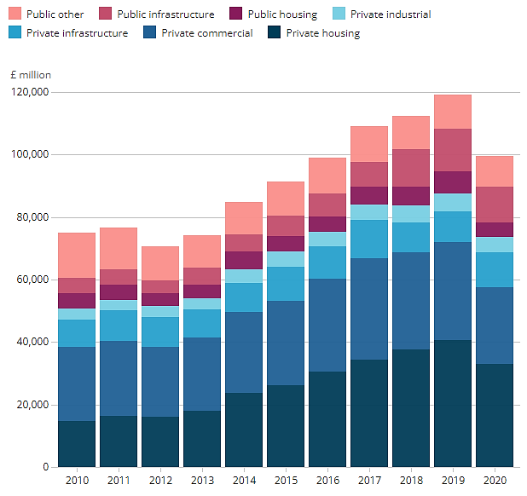
Figure 1: During Pandemic new work construction output and historical trend
In the year 2020, the total new work showed a drop of £19,436 million owing to the pandemic. The decline is considerable because of the financial crisis in 2009, which resulted in a loss of £14,082 million. Because no one was spending, private housing contracts were also curtailed, resulting in a 15% reduction in work and a 13.6 percent reduction in private commercial work. According to previous research, strategical power was necessary to tackle such obstacles as swift decision making, future implementation plans, and maintaining in the existing condition. Such a drop has had a huge influence on GDP, which will be explored further below, and was the primary cause of the financial market crash. (Ankan, 2021)
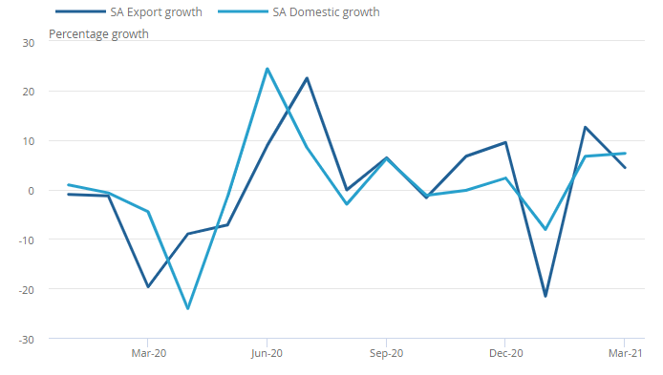
Figure 2:Manufacturing Industry Sales during Pandemic
Manufacturing is the second industry that is critical to economic growth and the development of the financial market. As shown in the graph above, there was a lockdown in March 2020, and export sales were lower. Since February 2020, the manufacturing industry has been on a 3.4 percent decline (Hongwei, 2020). The sales have shown significant volatility, and export sales have declined in December 2020. Because the businesses listed on the stock market are the primary participants, the overall impact on the industry was worse, which had a substantial influence on the financial market. Despite the efforts of policymakers and businesses, the pandemic's consequences lasted all year. Manufacturing businesses grew in 2021, however the market shrank slightly at the end of the year in December 2021 owing to a new COVID-19 variation. Now, in 2022, the epidemic has been contained, and businesses are expanding at a rapid rate. (Okechukwu, 2020)
The service industry is one of the most important contributors to the economy, with a growth rate of just 1.7 percent in December 2020, compared to 3.1 percent in November 2020. Although the experiences of the service industry in the face of the pandemic varied, the influence on the broader industry, which contributed to the UK's economic development, remained considerable. (Darren, 2020)
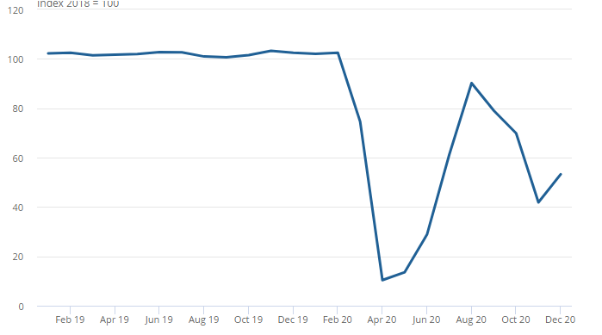
Figure 3: Food and Beverage Services Impact of Pandemic
The above Figure 3 clearly reveals that the industry was stable and that the sector had grown by 25.2 percent in December 2020, but that the rapid drop of 44.5 percent in February 2020, when the pandemic was at its peak, is visible from the above chart. Following February 2020, the result was a further weekend, as shown in April 2020, when the decrease of 55.6 percent was due to Pandemic. Restaurants, canteens, pubs, and other businesses in this area are rapidly expanding in the United Kingdom. Each industry was affected by the Pandemic and suffered significant losses. (Chantelle, 2021)
As the preceding discussion shows, the impact of the COVID-19 pandemic on the UK's industry is significant. Let's connect this to the UK financial market. These sectors form the UK's backbone since they employ large numbers of people and contribute considerably to the country's economic progress. Because the expansion of these businesses equals the growth of the economy, there is substantial government backing. The ensuing debate will focus on the declining GDP, which is due to the fact that all of the major industries, such as services, manufacturing, and construction, have suffered significant losses as a result of the COVID-19 epidemic. This resulted in corporations contributing less to the government, but it also meant that debts had to be paid off during this time. Companies can raise capital in one of two ways: through debt or through equity. When it comes to equities, there is a link between stock market indices. Investors will now base their decisions on the Company's financial state and performance analysis, which were both poor. Given the current economic climate, little investment was made, and interest rates were high, making borrowers' loans prohibitively costly. This clarifies the implications of COVID-19 on the financial markets in the United Kingdom. In the financial market, there was a sharp drop. (Marcus, 2020)
To deal with this unanticipated crisis, the government, policymakers, banks, and businesses have banded together. It is critical for them to stick together in order to live.

Inflation & Interest Rate and Impact on UK Financial Market
The rate of inflation is tied to interest rates, which in turn are linked to the country's financial market. When market inflation rises, it costs the consumer, the stock market, and the economy. When inflation rises, stock market growth slows, and stock prices become more volatile. High inflation has an impact on businesses since it eats into profits. When inflation is strong, consumer credit becomes more expensive because interest rates rise. (Vijay, 2021)
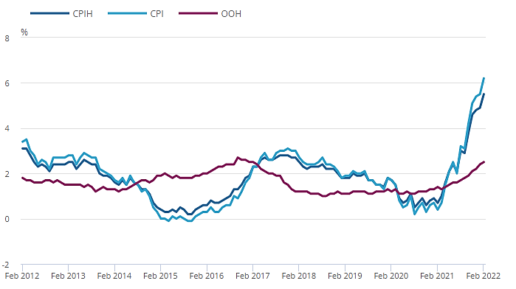
Figure 4: UK CPIH, OOH component and CPI 12-month inflation rates
The COVID-19 epidemic caused widespread disruption in all aspects of the market, particularly the import and export cycle, which was severely harmed by the cross-country shutdown. There were changes in consumer purchasing patterns as soon as the spread was launched. Consumer price inflation surged to 4.2 percent in October, reaching its highest level since 2021 (Chi-Wei Su, 2021). Gas and electricity rates are expected to rise by 12% through October 2021. Due to rising inflation rates, the cost of goods for businesses to make items increased dramatically. According to surveys, the British consumer price index climbed faster than expected. From 1.5 percent in April 2021 to 2.1 percent in May 2021, the inflation rate climbed by 2.1 percent. Inflation induced by the COVID-19 epidemic resulted in a significant increase in the price of commodities and costs in the United Kingdom. The graph below shows the spending trend from 2020 to the first quarter of 2021, indicating the influence of the COVID-19 epidemic on CPI. (Jennifer, 2021)
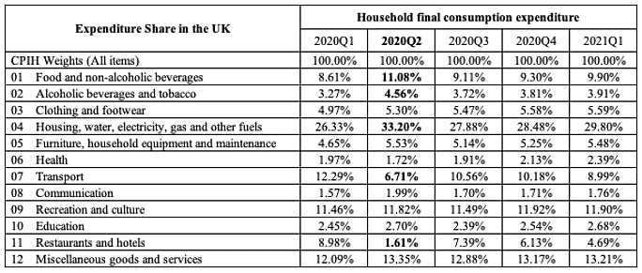
Figure 5: Expenditure Share in UK from 2020 to Quarter 1 of 2021
Because of the COVID-19 pandemic, the above data clearly shows that the expenditure trend in 2020 quarter 2 was different from the rest of the year. As soon as the first wave arrived, inflation rates began to rise, and the spread reached its apex. Inflation increased at a rapid pace during the last 12 months, with an average increase of 6.2 percent. Because the economy is now in recovery, the government is still combating inflation. In the 12 months leading up to February 2022, the consumer price index increased by 5.5 percent. (Xiaoyun, 2021)
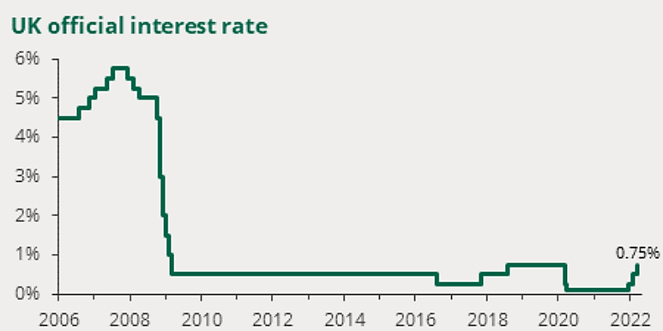
Figure 6: UK Official Interest Rates
As previously stated, interest rates and inflation rates are inextricably linked. Inflation rises as a result of the epidemic, which has a direct influence on interest rates. Interest rate hikes, on average, have a negative impact on the economy and financial markets. Because the Bank of England's Monetary Policy Committee (MPC) announced on March 17 that the interest rate will increase from 0.5 percent to 0.75 percent, which was predicted to grow by 8% through April, the accompanying chart implies that interest rates will rise significantly in 2020 and 2021 (Dayong, 2020). The policy makers made a strategic choice to deal with the impact of the epidemic, and in March, steps were implemented to combat the pandemic, including the division of interest rates into two stages so that the impact could be separated and the hot on the financial market could be managed. (Muhammad, 2020)
As a result of the foregoing debate, the GDP has taken a big damage, and the financial markets are in difficulty, particularly in 2020. The public's attitude toward spending altered as the inflation rate rose; manufacturing costs were high, resulting in a high inflation rate. Despite the fact that the financial market was down, strategic decisions were made, which are addressed in the next section.

Stock Market and Changing Behavior of Investors
During the epidemic, businesses were fighting for survival, and the majority of them were losing money. Investors consider the company's profitability, return on investment, and a variety of other criteria before making a decision. However, owing to the pandemic, the financial condition and performance were not excellent, and investors' behavior changed as a result. The study's findings clearly show that policymakers must consider a number of risks involved with the choice since it alters investors' perceptions (Regina, 2020). According to a previous study, investors in the financial market have a high risk tolerance when there is a big return. Because each unexpected occurrence might raise the risk and diminish the return, resulting in a loss of investment, the investor's risk assessment and choice is also reliant on market decisions. Investors follow one simple rule: the larger the risk, the higher the reward. (Fanyi, 2021)
However, owing to shifting market conditions in 2020, the stock market was down, with no new investors, and most existing investors withdrawing their funds due to losses. There was a great deal of ambiguity, making decision-making difficult. Covid-19 has an effect on the economic indicators that have been harmed by uncertain aspects, causing financial markets to malfunction. Aside from that, there were modest private investors who were there, the majority of them withdrew their funds throughout the epidemic.

Overall Impact on GDP, Economy and Financial Market in UK
The economy of the United Kingdom was struck unexpectedly hard, and the value of the stock market plummeted. The drop in the stock market is due to a number of variables, some of which were addressed above in the context of the COVID-19 pandemic. The economic situation has deteriorated to levels not seen in the previous 300 years. According to the National Statistics, the GDP of the United Kingdom fell by 9.9% in 2020 because no sector of the economy was unaffected by the epidemic. To limit the spread, the entire market was shut down, and every sector was losing money. The pace of inflation was tremendous, and interest rates continued to rise month after month. It was the largest drop in the UK economy since 1709, and the GDP shrank by 13% as a result. (Sobia, 2021)
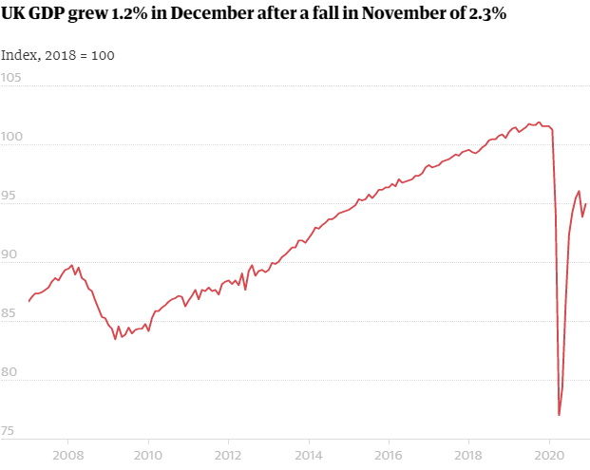
Figure 7: UK GDP from 2008 to 2020
Because of the government's limitations, industries like the services industry, which accounts for about 80% of the economy's output, have only grown by 0.6 percent. The UK economy was contracting in 2020, with a 2.9 percent contraction in the first quarter as the epidemic began to spread, and a 19 percent contraction in the second quarter. Then there was a 16.1% spike in the third quarter, followed by a third wave with much greater effects, from which the UK is still recovering. If GDP is calculated using the output technique, it grew by 1.9 percent in 2019 and then fell by 9.1 percent in 2020 following the pandemic. (Michael, 2020)
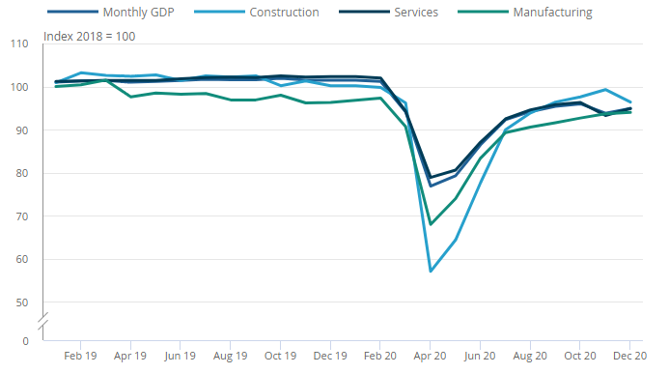
Figure 8: UK Monthly GDP along with industry movement
As previously noted, the construction, services, and manufacturing industries have all suffered similar losses as a result of the epidemic, as shown in the monthly figure above, along with the movement of monthly GDP. In 2009, when there were difficulties, company output fell by 7.8%, while in 2020, owing to a pandemic, production fell by 8.6%. Manufacturing declined by 9.9% in 2020, and a large drop in building has been projected. The key variables in the financial market downturn were all of these elements together. The recovery phase is depicted in the graph below, as the UK continues to struggle to recover from the financial market and economic effects of COVID-19. (David, 2021)
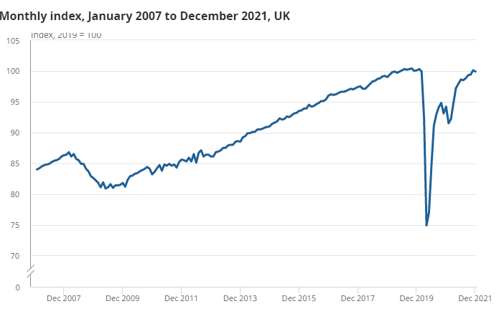
Figure 9:UK Monthly GDP index from 2007 to December 2021
In 2021, the gross domestic product (GDP) will continue to decline. GDP declined by 0.2 percent in December 2021, which is substantially lower than during the epidemic. The reason is that the major contributor to the economy, the service business, has decreased by 0.5 percent in 2021, but manufacturing has increased by 0.3 percent, and the construction sector has grown by 2%. Taking the entire year's results into account, the GDP grew by 7.5 percent in 2021. The December drop was caused by a new omicron Covid-19 variety. Now that the globe has regained control of the COVID-19 epidemic, the economy and financial markets are expanding at a rapid rate. (Liad, 2021)
The UK government is well aware that the economy and financial markets are still suffering enormous losses. Because enterprises and the general public were in a tough situation, the inflation rate needed to be kept under control. The strategic decisions were made by UK policymakers in order to stabilize the market. The drop in the interest rate was imposed during the meeting of the 2020 Monetary Policy Committee, and it was done in two stages. The banks have been requested to lower the loan interest rates. More money was handed to banks so that interest rates could be lowered and lending could be expanded. The government was actively involved in offering low-interest financing to enterprises in order to boost the financial sector and stabilize economic circumstances. The banks in the United Kingdom have decided not to pay dividends so that they can grow their lending. These variables had a significant role in stabilizing economic circumstances and restoring financial market stability. (Orestis, 2021)

Conclusion and Financial Market in UK Now
The purpose of this study was to look at the influence of the COVID-19 epidemic on the UK financial market. Several critical variables were highlighted for additional examination as part of the literature review technique. After a thorough examination, it can be established that the pandemic was a gloomy moment not only for the United Kingdom, but for the entire world. The financial market in the United Kingdom saw a sharp drop shortly after the first wave of the epidemic arrived. The month of February 2020 was the last month in which the market saw a major drop. There are various elements that contributed to the development of the country's financial market, and the influence on each variable may be described as follows:
First and foremost, it is clear that no sector in the country can be protected from the COVID-19 epidemic. The service sector, manufacturing industry, construction industry, and other industries are major actors and contributors to economic growth. The majority of corporations are listed on several stock exchanges, with the London Stock Exchange being one of the largest. These industries were severely impacted by the pandemic, as discussed in the preceding section, because a significant decrease in growth and profitability results in less contribution from companies, and investors are less interested in further investment, resulting in a drop in the stock market of the United Kingdom. A drop in significant industries signifies a drop in the country's economy, GDP, and financial market.
Other elements that have an influence on the country's economy and financial market include the exchange rate, interest rates, and inflation rates. The interest rates and inflation rates have a close link. Inflation rates were rising during the pandemic, as stated in the previous section, with the greatest level in 2021 and a 4.2 percent increase in consumer price inflation in October. Gas and electricity rates are expected to rise by 12% through October 2021. As soon as the first wave arrived, inflation rates began to rise, and the spread reached its apex. Inflation increased at a rapid pace during the last 12 months, with an average increase of 6.2 percent. As a result, if there is substantial inflation, the cost of doing business and living rises because buying power is eroded. Inflationary pressures produce interest rate volatility, and anytime interest rates rise, the financial markets suffer as spending patterns shift and money market stability is lost.
The COVID-19 pandemic was to blame for the abrupt drop in economic circumstances and GDP mentioned. As previously said, the United Kingdom's economy took a knock unexpectedly, and the stock market plummeted. The drop in the stock market is due to a number of variables, some of which were addressed above in the context of the COVID-19 pandemic. The economic situation has deteriorated to levels not seen in the previous 300 years. According to the National Statistics, the GDP of the United Kingdom fell by 9.9% in 2020 because no sector of the economy was unaffected by the epidemic. To limit the spread, the entire market was shut down, and every sector was losing money. The pace of inflation was tremendous, and interest rates continued to rise month after month. It was the largest drop in the UK economy since 1709, and the GDP shrank by 13% as a result.
Following the epidemic, the UK financial system and worldwide economy are now beginning to recover from the effects of COVID-19. However, there is still a chance of recovery. According to the Financial Policy Committee (FPC), the United Kingdom is now regaining financial stability. There is still a risk as a result of debts incurred during the epidemic. Overall, the financial market is far more stable now than it was during the height of the crisis. The FPC establishes a countercyclical capital buffer for each quarter of the year (CCyB). This is a strategic method that allows banks to cushion their losses with greater capital. This is because the COVID-19 is regulated but not terminated, and if an unforeseen incident occurs, the bank can release the buffer to assist UK families and companies, ensuring economic stability and smooth financial market operations. Bank conditions and liquidity situations are now robust, and they are in a position to help households and companies in the United Kingdom.

References
Abdussalam, S. D. H. N. S., 2020. The Effects of Pandemic on Construction Industry in the UK. Mediterranean Journal of Social Sciences, 11(6), p. 48.
Adedapo, S. K. R. A. a. J. O., 2017. Effects of oil price shock on stock returns of energy firms in Nigeria.. Kasetsart Journal of Social Sciences. https://doi.org/10.1016/j.kjss.2017.09.004.
Albulescu, 2020. Coronavirus and financial volatility: 40 days of fasting and fear. Computational Finance.
Ankan, B. A. G. A. K. T. M. B. G. D. K. B., 2021. The impact of COVID-19 in the construction sector and its remedial measures. Journal of Physics: Conference Series.
Atkeson, 2020. what will be the economic impact of COVID-19 in the US?. Rough estimates of disease scenarios. NBER Working Paper, No. 26867.
Baker, S. N. B. S. D. K. K. M. S. a. T. V., 2020. The Unprecedented stock market impact of COVID-19. NBER Working Paper Series, p. 26945.
Barrafrem, K. D. V. a. G. T., 2020. Financial well-being, Covid-19 and the financial better than average effect. Journal of Behavioral and Experimental Finance.
Bastianin, A. F. C. a. M. M., 2016. The impacts of oil price shocks on stock market volatility: Evidence from the G7 countries.. Energy Policy, p. 98: 160–169.
Chantelle, R. M. R. M. F. B., 2021. Environmental impact of personal protective equipment distributed for use by health and social care services in England in the first six months of the COVID-19 pandemic. Journal of the royal society of Medinice , 115(5).
Chi-Wei Su, K. D. S. U., 2021. COVID-19 pandemic and unemployment dynamics in European economies. Economic Research.
Darren, F. E. M. N. B. J. S. M. B. L. A. N. M., 2020. COVID-19 pandemic in the United Kingdom. Health Policy and Technology, 9(4), pp. 673-691.
Dave, A. S. B. J. M. B. N. B. P. B. S., 2020. Economic uncertainty before and during the COVID-19 pandemic. Journal of Public Economics, Volume 191.
David, H. R. H., 2021. The accounting, budgeting and fiscal impact of COVID-19 on the United Kingdom. Journal of Public Budgeting, Accounting & Financial Management, 32(5), pp. 785-795.
Dayong, Z. M. H. Q. J., 2020. Financial markets under the global pandemic of COVID-19. Finance Research Letters, Volume 36.
Delatte, A.-L. a. G., 2020. COVID-19: a new challenge for the EMU, CEPR Discussion Paper No. 14848. Centre for Economic Policy Research, London.
Elliott, L., 2020. The coronavirus crisis may lead to a new way of economic thinking. The Guardian..
Fanyi, W. R. Z. F. A. S. M. M. S., 2021. Impact of investment behaviour on financial markets during COVID-19: a case of UK. Economic Research.
Gabriel, L. F. M. d. C. D. F. S. F., 2020. Circular economy in the construction industry: A systematic literature review. Journal of Cleaner Production, Volume 260, p. 121046.
Gormsen, N. a. R. K., 2020. Coronavirus: Impact on stock prices and growth expectations.. Becker Friedman Institute for Economics Working Paper, No. 2020-22..
Heyden, K. a. H., 2021. Market reactions to the arrival and containment of COVID-19: an event study. Finance Res. Lett. , p. 38: 101745.
Hongwei, H. L. H., 2020. The impact of Covid-19 pandemic on corporate social responsibility and marketing philosophy. Journal of Business Research, Volume 116, pp. 176-182.
Jennifer, L. C. J. A. D. D. F. H., 2021. THE VALUE OF ROBUST STATISTICAL FORECASTS IN THE COVID-19 PANDEMIC. National Institute Economic Review, 1(1), pp. 19 - 43.
Le, T. a. Y. C., 2015. Effects of oil price shocks on the stock market performance: Do nature of shocks and economies matter?. Energy Economics 51: 261–274..
Liad, B.-B., 2021. COVID-19-Related Economic Anxiety Is As High as Health Anxiety: Findings from the USA, the UK, and Israel. International Journal of Cognitive Therapy, p. 566–574.
Li, W. F. C. H. K. T. A.-D. M. S. V. N. a. F. T.-H., 2021. The nexus between COVID-19 fear and stock market volatility.. Economic Research-Ekonomska Istraživanja..
Marcus, R.-B. H. T. W. J. R. D., 2020. The impact of Covid-19, associated behaviours and policies on the UK economy: A computable general equilibrium model. SSM - Population Health, Volume 12.
Mckibbin, W. a. R. F., 2020. The global macroeconomic impacts of COVID-19: Seven scenarios.. CAMA Working Paper Series, 19/2020..
Michael, A. S. J. A. L. I. S. M. T., 2020. The Financial Market Impact of Quantitative Easing in the United Kingdom. International Journal of Central Banking, pp. 1-49.
Michael, L. A. R., 2016. Towards circular economy implementation: a comprehensive review in context of manufacturing industry. Journal of Cleaner Production, 115(1), pp. 36-51.
Mohsin, A. N. A. S. A. R., 2020. Coronavirus (COVID-19) — An epidemic or pandemic for financial markets. Journal of Behavioral and Experimental Finance, Volume 27, p. 100341.
Muhammad, A. S., 2020. The response of financial market indices to covid-19 pandemic. Financial Studies, 3(89), pp. 83-92.
Niall, O. D. S. B. S., 2020. Immune or at-risk? Stock markets and the significance of the COVID-19 pandemic. Journal of Behavioral and Experimental Finance, Volume 30, p. 100477.
OECD, 2020. Coronavirus: The world economy at risk.. https://www.oecd.org/berlin/publikationen/Interim-Economic-Assessment-2-March-2020.pdf.
Okechukwu, O. R. S. F. C. J. P., 2020. Manufacturing in the Time of COVID-19: An Assessment of Barriers and Enablers. IEEE Engineering Management Review, 48(3), pp. 167 - 175.
Orestis, Z. S. B. K. B. T. K. H., 2021. How does the COVID-19 pandemic impact on population mental health? A network analysis of COVID influences on depression, anxiety and traumatic stress in the UK population. Psychological Medicine, pp. 1 - 9.
Ozkan, 2021. Impact of COVID-19 on stock market efficiency: Evidence from developed countries. Research in International Business and Finance.
Ozkan, O., 2021. Impact of COVID-19 on stock market efficiency: Evidence from developed countries. Research in International Business and Finance, Volume 58, p. 101445.
Pak, A. O. A. A. A. K. R. E. M. a. D. E., 2021. Economic consequences of the COVID-19 outbreak: The need for epidemic preparedness. Frontiers in Public Health, p. 8: 241.
Regina, O. M. P. S. T. W., 2020. COVID-19 and investor behavior. Elsevier Public Health Emergency Collection.
Rehse, D. R. R. N. R. a. J. Z., 2019. The effects of uncertainty on market liquidity: Evidence from Hurricane Sandy.. Journal of Financial Economics , p. 134 (2): 318–332..
Sherif, M., 2020. The impact of Coronavirus (COVID-19) outbreak on faith-based investments: An original analysis. Journal of Behavioral and Experimental Finance, Volume 28, p. 100403.
Sobia, N. M. M. W. H. G. L. K. P., 2021. The Investor Psychology and Stock Market Behavior During the Initial Era of COVID-19: A Study of China, Japan, and the United States. University of Castilla La Mancha, Spain, p. https://doi.org/10.3389/fpsyg.2021.626934.
So, M. A. C. a. T. C., 2021. Impacts of the COVID19 pandemic on financial market connectedness. Finance Research Letters.
Taghizadeh, -H. F. N. Y. a. H. P., 2021. Analyzing the characteristics of green bond markets to facilitate green finance in the post-COVID-19 World.. Sustainability, p. 13 (10): 5719.
Vera, V., 2021. The persistence of financial volatility after COVID-19. Finance Research Letters.
Vijay, V. J. J. K. S. L., 2021. From a Recession to the COVID-19 Pandemic: Inflation–Unemployment Comparison between the UK and India. Economies, 9(2), p. 73.
Wu, F. Q. H. C. Z. H. W. Q. Y. a. H. S., 2021. New structural economic analysis of anti-COVID-19 pandemic model of BEST region.. International Journal of Environmental Research and Public Health , p. 18 (15): 7822..
Xiaoyun, W. L. H., 2021. The impact of COVID-19 pandemic on transmission of monetary policy to financial markets. International Review of Financial Analysis, Volume 74, p. 101705.
Yoshino, N. F. T.-H. a. M. O., 2021. Covid-19 and optimal portfolio selection for investment in sustainable development goals. Finance Research Letters.
Yuntong, L. Y. W. Q. W. Y. L., 2022. International stock market risk contagion during the COVID-19 pandemic. Finance Research Letters, Volume 45.
ZEREN, F., 2020. THE IMPACT OF COVID-19 CORONAVIRUS ON STOCK MARKETS: EVIDENCE FROM SELECTED COUNTRIES. Bulletin of Accounting and Finance Review, Volume 3, pp. 78 - 84.
Zhang, D. H. M. &. J., 2020. Financial markets under the global pandemic of COVID-19. Finance Research.

